# Ｐｒｏｌｏｕｇｅ

Ａｆｔｅｒ　ｗｏｒｄｓ　ａｒｅ　ｎｅｖｅｒ

ｔｈｅ　ｅｎｄ

Ｔｈｅ　ｅｎｄ　ｉｓ　ｎｅｖｅｒ　ｔｈｅ　ｅｎｄ

Ｙｏｕ　ａｒｅ　ａ　ｆｏｏｌ　ｉｆ　ｙｏｕ

ｂｅｌｉｅｖｅ

ｔｈａｔ　ｔｈｅ　ｅｎｄ　ｉｓ　ａｃｔｕａｌｌｙ　ｔｈｅ　ｅｎｄ

My eyes flare up and a jolt comes at me. Panting heavily as thoughts bounced in my head far too clearly. the feeling of piercing spears spewed down from the heavens. But looking up I see trees with the sound of splashing water all around me. it is…Pouring. And I am…exhausted.

Pained…shocked... I couldn’t tell if I was crying or if it was the rain. I couldn’t tell. My whole body is in ruins. fractures, bone breaks. If I knew any better, I shouldn’t be alive. I am probably crying cause I want to die.

I don’t deserve to be alive.

Not in this world. Not here. Not without them.

My head was full of thoughts that couldn’t be thought of. My brain fighting off the rules. Fixing oddities that shouldn’t exist. The world had already failed that.

Heh…It’s just a severe headache at this point.

Did I fail? Did I do this? Could I have stopped this? or is this another random reason to boost my own self-loathe?

I am losing it aren’t I?

A sudden splash unlike the mud alarms wakes me. an object. A white Mask fell beside me, one that I owned and one that fell from my head. A white Mask with a cartoonist grin on it from one side till the other… it’s Dreyvas’s last gift to all of us… sitting in the mud. Starring at the mask without an expression. Tired, alone and dazed… I didn’t know what to do anymore. my hand reaches for the mask with a tremble. It hurts so much. Pointing the eyes of the mask towards me, it staring at me and I starring at it. The mud had stained its laughable smile. *Everyone* was here.

## Mask image

Then a thunderclap, and a lightning flash just after. The brewing storm was ending. Daybreak behind the clouds and the sunrise was about to greet me.

And with my first sunrise came with it a first-Born’s cry.

They were in my arms. having a few of the subtle declining rain patter on them through the thick tree leaves. The Thunder must’ve woken them from their slumber. When did the bubble pop?

But gladly. Unlike me. they were totally unharmed.

“Koursun.”

it meant *beautiful Soul*

“Come on, Come on, Don’t Cry Koursun. It’s okay” I try to speak softly, but my voice came out raspy and vibrated oddly. “Papa is here” I bring Koursun lightly into mychest. Letting go to see their sobbing face, but even while sobbing, their eyes shined different than any other pair of eyes I’ve seen. What beautiful eyes. A Green that transformed into the red sunlight behind us, only to refract the sky turning blue above us. It didn’t take a second to see what it meant. “Iridescence?” huh, “I didn’t know you’d be so strong” I bring Koursun up to give them a kiss again. One that instantly spread a serene seed of peace over their mind. “it’s okay, Koursun.” I whisper “I’ve found my resolve again.”

My beautiful.

Beautiful,

Koursun

-END OF TRANSMISSION-

ＢＯＯＫ　１

# ＣＨＡＰＴＥＲ　1

W a k i n g U p W a s a M i s t a k e

*Beep* *Beep*

*Beep* *Beep*

*Beep* *Beep*

*Beep* *Beep-

I close the alarm with a wince as I get back in bed again. The static is back. rising in tangent with the footsteps down the hall. I hold my head and cover my ears. It hurts so badly today as well. I already fuck’n hate today. Does it really have to get worse?

I glance at the skipping sound of footsteps kicking my door open, with each step the static spikes in my head, forcing my eyes shut with each sound. The door swings open with a crash. Brown haired, green dyed Tiph comes out the dark hallway “Good Morning li’l sis!-“

Who the shit cares “Get OUT!” I yell, Giving her the finger as from under the blankets. My head hurts too much to care

“h-hey, I haven’t even done anything yet”

“I don needa reason to tell you to fuck off. **so** **OUT**!”

Tiph scoffs, rolling her eyes. “next time, you either fix that mouth of yours or I am staying here till the next day” she said, walking out the door and closing it behind her. I sigh with the static and stretch. But the door creeks open again. “Got it?!”

she just had to come back “alright! Alright, just ef off already”

“Not. Funny” she pointed, slamming the door behind her. Now I was all alone.

I get up from bed. Sleep and rest never come back from just lyin’ there so what good will it do? I frown at the thought. Of never being able to rest well properly. The static was too strong, too loud. Too painful to ever let me sleep, at day, or at night. I am surprised I even get to wake up. I never remember sleeping in the first place.

Unbutton my pyjama top as I take my new school shirt from my chair. Yep, I hung it on my desk chair so it’s right there when I wake up. no need to find it in the closet if it’s right there. But even then, I hated it. The jacket, kilt, And Cardigan’s green. I don’t even know someone who likes the colour green and the price tag just isn’t worth it. Tiph was foaming at the Mouth and she didn’t even pay for it. Does it really have to be green? I thought the school buildings were blue. I turn on my phone on the desk to check the time and let that ancient thing take it’s time to turn on. Dad’s old phone. The best thing it has is snake and that’s it. It’s too old to use the internet, but old enough to call.

Since It’s winter, the room’s cold, so was the ceiling, the walls and the floor. Even the shirt I put on. As if long sleeves actually did anything but spread the cold over my arms. Black leggings named colder than ice and a green ugly kilt came in second, not too rough to put on, just a finicky clip that’s stupid to put on. the jacket came in last, It has a nice inside feel. Cotton? maybe. I wonder how it would feel if it’s warm.

My bag was right in front my favourite ugly wardrobe, with its only unique feature being it’s mirror on the sliding door. I pick up my bag and get a look into the mirror at this thing.

Not too bad? maybe. not one to care much about looks but the clothes were new, not too bad in the comfort department. Kilt was long enough like a kilt. And I am short enough like a kid. Messy hair all the way. “Nikki goes all the way.” Heh. I see myself scratching my head in the mirror with a smirk. When was I so good at rhyming?

## ­ Nikki!

The chime of my phone wakes me up from my daydream. I go snatch it and head to the door running. 7:28, shit. I might be late.

A spike of the static made me lean back, limbo style under a hand that was about to flick me in the head with its finger. “shit, girl, you weren’t even lookin’” Tiph says skipping by into her room “have fun at school” and that has got to be the most stupidest thing I’ve heard. She goes to collage and knows that I hate school. And you’d think she’d be smart by now to tell that. She skips school till who knows when And I’m the one who has to wake up at early hours for the next forty weeks.

**And she tells me to enjoy school**

I let my hands wild over my head. Stomping out to the kitchen, I find mom preparing food for us. “good morning, Nikki. sle-”

“lunch” I say in response.

But she looks…pissed. What’s with that look? she comes one step closer and raises her wooden spoon.

*Bonk*

“OW! Did you just hit me with a spatula?” the pain of the static spikes in my head, making what I thought had calmed down. I see red on the spatula “is that blood or is that sauce!?” fumbling over my head for any sauce that could’ve gone on there

“no, I hit you with the back end of it. I at least have some decency in my actions” she said. Spinning the spatula like a veteran gunner to her hip.

No, that’s not right. how could someone slap me with the backend of a stick while holding it upright?

“no#, s## it ag##n ###ase”

“say what?”

mom sighs, but her voice reverbs and keeps echoing in my head. “your lu##! About yo#r ##nch Nikki. You need to ask for it nicely” I can’t make it out. and the static isn’t too nice about it either, it’s getting stronger as well.

I can’t hear her. “alright, alright. I am sorry.” play along. It’s the Best thing I can do right now.

Mom sighs again, folding her arms. I’d think she’s mad if I didn’t know any better. But she’s never mad. She smiles just like now. I don’t know how she does it. how does she handle all of us? “Count your blessings, Nikki. Lose sight of them, and you’ll never see them again. alright?”

“…that’s deep?” Why did I hear her that time?

“aaaand your lunch box?” Her hand reveals the shiny blue box that I yank and pull away, but it doesn’t budge. Fucking gorilla strength. “ah, ah. Ah! Say nicely first”

Ugh “fine. fine. may I PLEASE have my lunch box. Am gonna be late.”

“alright, here you go.” finally, she let’s go of it “go to your dad, he’s waiting”

“See ya”

But before I could go anywhere. My collar gets yanked backwards with an arm turning me around. It was quick, and it was mom. Looming over me with her arms loopin’ around me “Nikki.” She said, coming closer “what did I just say about counting your blessings?” giving me a hug that made all the cold get out of my world. A hug so warm I just had to give it back “if anything happens. Remember to call me. You got your phone with you?”

I nod.

“alright then.” Mom’s voice is starting to become quieter and clearer as She leans back and gives me a peck on the forehead before letting go “stay safe, alright?” she stands back as a quiet ringing starts to come to my ears “don’t you have somewhere to go?” she said. Didn’t notice it but she was already in the kitchen. The static ringed in my head again. growing louder and louder and I know this feeling too well. ‘Am used to it. I brace myself. And a car horn shouted out from the garage door. But the pain was deadly. I grit my teeth as I bare it. Clench my bag as I hold it. It hurts so much I might just cry, maybe am about to fall.  
But there’s no point in doing that, is there? “Nikki, are you alright?”

Not a single reason.

I get up from the floor and jog to the shoe rack without a wince or a limp. Grabbing my shoes, I ram the door open and keep running to the open car door. I hear mom say something, but I was too far gone to listen. I jump into the car and its engine roars as dad leaves the driveway.

ＢＯＯＫ　１

# ＣＨＡＰＴＥＲ　2

T h a t g i r l

The trees pass and so does the grass. All the green of the world passing by. Houses of all shapes and colours,

And the white snow of the sky refuses to leave me by.

That felt like a nice rhyme.

“You sleep well, sugar?” Dad asked from the front seat.

“No, you didn’t need to send Tiph to wake me up, she just makes my day worse every time.”

“didn’t do that. That was all your sister”

Ugh “of course it had to be” there’s really nothing in here to do other than to simply wait the car ride out. not that it was bad. It was, but it’s getting better.

I look out the window for the snow in the sky started to slow and white buildings with red parts started to show. “We’re here” says dad. “Come on. Don’t get weak legs on me now”

I jump out from the car to face the cold breeze of the morning, slamming the door behind me. I feel something change about the static as I remembered a funny story. “Hah! Didn’t you freeze up on your first day?”

Dad joins me outside “Ooi, don’t act like you were there. That’s just what your mom says”

“and she’s always right~”

Dad chuckles “since when did you tease? I haven’t seen you grin like that in ages! Yer lookin’ like me hon.” dad gave off a silly grin. I could almost appreciate him for it If it weren’t for the static. I’d love it more. Like it more and smile with him more, but whenever I look at his face, it stings, it hurts and I can’t help but look away from it… Why am I thinking like this? I never think like this. A hand drops to my shoulder, making me jump “you alright, sugar puff?”

“I am fine” The whole school’s in view “just don’t ‘*sugar puff’* Me, dad.”   
A large green field doubling the school’s buildings. Packs of students littered the field all wearing green. Leaving their parents hands and going to the pile of every other boy and girl. wonder what they’re feelin’, leaving their parents like that. I wonder what I’ll feel in the next ten seconds

Dad walks with me to the ring of parents “well, time to go.” He said, pointing off to the pile of green students “your class’s over there. think you can see it?”

“nah, ‘am blind.”

“Doubt that” he chuckles “But just call me if ya need anything” he says, patting my back and sayin’ nothin’ more. And I wouldn’t want it any less. I take a step forward as one thought sprung up from my empty stupid head that stops me right in my tracks.

“…Nikki?” dad called out to me “you all right?”

“yeah, yeah. It’s just, cold” I said “it’s cold” and I hate it.

“not too cold is it?” dad asked as a hand perched on my shoulder. “there’s always room for another first day legacy in the family.” But I shrug it off.

“’Am good.” I storm off into who knows where. lift up my collar and zip up my jacket for once. maybe stealing a scarf from Tiph would’ve been useful today. Letting out another puff into my hands to rub together “paaaahhh.” starting to doubt if even a scarf would help. Hell. All her scarfs look nasty either way.

It’s not hard to pass through the crowd when you’re this short. Ducking, weaving and past all the chit chatting idiots as they chummy wummy with each other. Either too many people know each other, or it’s become the norm to hug people around here.

Asian, black, pasty, Caucasian and all other skins and kinds of people; curly, straight or blonde, even dyed. I won’t have trouble finding things to draw, am sure of that. But bizarrely, everyone is still fucking tall.

…

The static is getting quieter.

It… I look around looking for it, it’s not even a thing I can see but only hear in my head, what am I doing? Everything is silent. No, wait

It’s there, just not loud enough to hurt. Not enough to hurt my ears, hurt my head, make me dizzy or make me fall. right now.

I don’t feel that.

light. That’s what I feel. like my head both weighed nothing, and felt like nothing. frozen in ice. It’s like I am not there. The weather went right through me. It was cold in my jacket and under my shirt. The leggings didn’t even matter at this point. What is this feeling? Being cold all over? I let out a puff of warm air, with it turning into warm vapour right in front of me. it’s still cold and in the morning, and that hasn’t changed as a shiver goes through me.

it’s getting hard to breath.

I can barely hear a thing anymore.

Poke a finger in my ear and no ear wax comes out. my brain’s just dying, isn’t it?

Everyone’s getting quieter and quieter. people kicking the wet frosted grass onto other’s socks and knees and well, I kick water at a few people. Two appeared to have shouted at me while a third kicked back with a with their mouth animated, laughing I am guessing. But what bothered me was the cold that went right through me one way and out the other. as I sit down in my line. I look back at dad and see him choke holding some other guy, waving at me once he saw me, must’ve never let his eyes off of me… Should I be concerned for the other guy?

Another stupid thought just came. I can’t hear anyone’s voice anymore. The ruffle of grass was quiet. Like a cold quiet room. My eyes trail around and the snow in the sky stayed still and solid. Not moving a muscle if it had any. I look behind me to see everyone around was moving, but moved slowly.

There’s no crunching of frost or grass anymore. No more bumping, no more laughing and no more talking. There was no sound to begin with.

And worst of all, I feel…calm.

Like, I could just, lie here and sleep if I wanted to. And I hate that. Am’ not used to it.

It’s so peaceful and just. -Is five minutes of not having the static is all it takes? I’ve never felt this rent free in my head that I close my eyes to embrace it. Every thought so loud and clear. Can’t things just stay like this?

But the sound of rustling clothes made me open my eyes. What made that sound? A girl sitting right in front of me, waving somewhere in the distance that didn’t seem to wave back. like a hidden cherry gem amongst the people. Her hair was a black red, dark from the top, but lighter at the tip of each strand in a nice neat form, waving down a bouncy river. Her hair was thick, thick enough to cover her ears. Her frame wasn’t big. Or really just, not one I could make out from behind. The only thing I knew is that if we were to stand, we maybe the same height. Hell, maybe am even taller. Her uniform’s something else though. it seemed so much nicer on her than anyone else’s. It just seemed different and I don’t know why. Was it the colour? The shade of green?

Another rustle of came from her as she shifted in place. To turn around and look somewhere else, somewhere behind her. we lock eyes in that moment.

It didn’t feel like there was time. I could see it all in the corner of my eyes. Everything, stopped. leaning towards me with one arm to lean on and the other covering her mouth, and even that was covered by her long sleeve. close, but far, turned to face me but not all the way. I could see her Cardigan under her Jacket now. I could see her face and how pretty it is now, her hair messy all round with something shining behind it. her eyes, big, round and more colourful than her jacket. green, blue and a deep dark red, all of those colours there at the same time, and, just, how can something like that exist? Moments stretched into seconds and maybe even minutes before the girls gaze swerved to the right as her cheeks clearly redden, she looks back at me, getting her arm back and now sitting up right. She smiles, waving. Her smile was so small, it made her whole face seem so soft. It finally ticked that she’s waving at me. I wave back with a hand stiffer than a rock.

The Girl winced as she leaned forward. quickly covering her ears, and other’s. everyone around’s covering their ears, what’s going on?

Ou…I can hear it now. A siren? The girl rises up again. Her smile almost gone but holds onto it. She looks back at me and tries to smile again. she’s, hurt. But waves again. I thought she was about to cry until something from her pocket buzzed and light appeared, I saw and she felt. her frown disappearing for a second as she smiles only to close an eye half shut. She looks at me, leaning forward and back as rocking and turns forward. Her face, just. Does-is she? Is she hurt? Did she just bow?

WHOOOOLE

Paaaage

Resseerrrved

## For Koursun

All around, everyone’s just looking at the front, at a podium with an old man standing on top of it.

*[“well what a fine good day it is!”*

*“I hope you all-”*

*small*

*]*

What’s… he saying? My head still feels light. And I can’t hear him. I can’t hear a thing. The girl in front of me took her hands off her ears slowly now as she watched as well. The snow in the sky’s still frozen in place…

And I just. Have nothing to do…

Do I just. Sit here? Sit out this… silent speech?

Plucking at the wet grass with nothing to do but listen.

So… wait it out… huh?

Pluck the moist grass. And twist it… maybe make something with it. oh, a dandelion… wonder when I learned this… A white flower. Is it a Lily or is it a Jasmine? I pluck more grass for my new addition. It’s quite fun to make something like this. how do I know this? To twist here and twist there. The joy of making, the joy of creation.

The dizziness, this light feeling just won’t go away. Every time I blink I wish my eyes would stay shut. To wake up in bed and finally well rested… it’s hard to stay awake, might just doze off here if anything…

But the cold just keeps me awake. It’s like I am not really there, I swear I can feel the wind bounce in my clothes right now.

Am I on Everest or something?

But the flowers. Are so easy to spot and too many are at arms length, asking to be picked up and made into a crown.

Wrap...tie... an’ do it again.

Wrap...tie... an’ do it again.

Wrap...tie... an’… done.

Heh, it’s done. When was the last time I did this? Is this the first? i lift it up and look through it. turning it around under the grey sky just to see how it looks.

It’s pretty.

People around were shiftin’ too much now. everyone’s moving. Getting a grip on their bags with the ol’ man at the podium nodding. Saying a word that couldn’t be heard. And raises his arms. And everyone stood up with it. that’s my key to go. Or at least the end of this fantastic speech. I grab my own bag and crowned myself. It’s wet, damp and probably disgusting to be honest, but I built it, and if I don’t wear it with pride. Then no one will. And I don’ want that.

better get a move on if I wanna get to my class.

Can’t find friends for life without looking for them.

_

-

-

## sdaShadow starts

-

-

-

-

-

-empty black pages

I can put an easter egg here

-

-

-

A light is shown

Hands are shown, slender and small

The light gets brighter

And there’s a glass breakage

And she breaks out

The darkness fades away, and now Nikki is here, mid way jumping out

You see her face a little bit shocked and confused

Her dialogue “what?”

## jump

I feel the wind blowing into my eyes, somethin’ cold over my head. And a smile spread over my own face, one that ain’t mine. I feel my legs folding as they touch the ground with a force thrusting forward. The ground came hurtling, only stopping as a shock travelled through my arms, ending at my shoulders. Heavy, weak and a little bit dizzy. God what the hell, wasn’t I just on the field? “GET BACK HERE YOU RAT!”

“*run!”* Fuck. “*run!”* I need to run. Get up, Get up! it’s just a little sore and nothin’ more! My feet move first, and my hands push second. Tumbling a little but I am running an’ I keep running. all the buildings way too large with shadows that oversaw, with trees an’ grass an’ bushes laid on all about. A rain shelter that covered the skys held up by metal, a little taller than a door with roots that reached every turn I go.

My legs start to give away as I grab onto a pole, swinging around it for a sharp turn and into slow hops that turned a quick halt. My panting turns into wheezing for air while I hobbled forward. “fuck,oh fuck *\*Kahk\**. My throat hurts.” The air’s too cold for running like this *\*wheeze\** fuck. I can barely breath-*\*Cough* *Cough*.* I think I’ve scorched my own throat, it’s worse than having a cold, *\*Cough* *Cough\**

*“Grasping for air colder than ice.”*

*“just, stand up, and take a deep breath”*

Yeah, like hell’s that gonna work…let’s do it. I Stand up an’ look up at the snow fallin’ through the cealin’. and finally breath in…

*\*Chokes\**

Fuck! \**Cough*\* \**Cough*\* “that’s *\*Kahk\** fuck’n impossible *\*Kahk**Kahk*”*

I think I might die at this point. *\*cough*…*cough\**

It’s not so bad if I hold it in a little *\*cough* *scoff\**

# ＣＨＡＰＴＥＲ　3

This school

Some blocks and some grass. Some trees and some stairs. Blue stairs instead of the grey sky. Grey birds flying overhead to chirp and tweet. And here I am, lost in a palace of wonderland. Grass was planted everywhere even in the school grounds, whoever built this place, liked grass, or at least, really knew how to make a school greener, but one look at my vomit uniform and by this point, why am I not surprised. Buildings were tall, or am just that small, because all the windows are too high to even look through.

But No one’s around and everyone’s gone, The snow in the sky keeps falling through the roof, even through my own hand.

Wonder what real snow feels like. Not this kind. I don’t even know what this is and I just call it snow. I look up from, and I’m at an intersection of open space. I could go anywhere I’m not meant to go

“*sigh* How’d I manage it? how’d I end up falling there?” am not even going to mention the walking into a pole. Just how did *I* get here is the biggest problem.

It’s like the backrooms all over again but instead it’s real life and not a video game.

One minute am’ on the field, the next second ‘am running for my life for no reason, added with that smile that I had on my face, that feeling of euphoria that quickly disappeared as I fell

I take a deep breath, And breath it out. making me feel even more light headed like a drug that’s bein’ sold free. All because of the static being long gone and just how cold it is outside.

But, It’s still there. The static, I know it. it’s just gotten too weak to hurt.

I-’ve been wishing for it to be gone for how long now? a few months? Has it -even been a year with this headache?

Wow. How did I hold onto it for so long?

I sigh. This is just. Great. How do I? find my class?

In front of me is this long narrow hallway with no walls. It’s just a long roof with metal poles to hold it up, stretching to the building that’s practically forty meteres ahead. Only splitting to go either left or right…

It’s probably a good starting point.

## Shelter image

Scenery, co

mage here]

The endless rain shelter of a walkway just keeps on going as I take lefts and rights. Touching the snow for it to fall through my hand and everything still looks the same from five turns ago…

But this right. Is different.

Instead of a grey wall or another path. A green hedge twice my height was only a few feet away. the pavement still continued over there like normal but a patch of grass took the right half of the walking space. and right beside it’s just the corridor again but lifted up from the ground just to trip anyone that’s not looking. With this and the maze layout of the school, the designers were followers of lucifer certainly.

There’s open space behind the two-metre-tall hedge. I can see blue and the green field behind it just through it almost to the left. That’s open change. And that’s something that I very much need from this open lightness in my head.

I go out to the hedge and over the crude concrete. and to my left an opening. A bunch of coloured picnic tables were all set and about, All of them varied in colours and choices; Black, green, Yellow, lime and an infamous rainbow just 3 benches away. It’s quite cute. 8 sides with an octagon design, it just feels right to see here. Who made these? I brush my hand over them while passing by, feeling the soft wood and the dry paint. It’s definitely new, no one’s ruined or even thought of touching it yet. I guess students from end of last year made them and no one got the chance to sit on ‘em.

… The snow’s…slowin’ down in the air. it’s barely moving anymore.

## Image of Nikki looking up and touching the snow. 2 panels

]

Metal pillars loomed over for no reason, even if two of me stood on each other’s shoulders ‘n jumped. We’d never reach the top of it. do the designers really want people to smack face first into stuff?

As I walked, I quickly hid into the pole’s shadow again.

Cause the girl was there again.

She was there, on a small ramp leading to the door with a railing that she held lightly, even from here with all the snow I could see her. And her eyes so lost that she must be day dreaming, how can I see that far? Her brown red hair practically glowing against all the blues and whites around it. standing there without a purpose in her navy pattered green kilt.

The snow frozen solid all around us. she hasn’t noticed me. yet, a gust of wind flies by, freezing me solid as it passes through everything I wore as it flaps with the wind for a second.

And the girl by the rail had the leaves blow all around her, as they travelled, she smiled. Catching a petal before letting it blow away.

Suddenly a guy seemingly came from the right of me, but on the other side of the bush, instead of going to the left like me, he went straight forward. thin but tall, hair dyed blonde. Walking fast in quick paces, leaning forward, hands in pockets, looking for trouble. I started to move myself. He’s not slowing down and I don’t like where this is-

That blonde fucker shoved the girl out of his way and into the railing. I dash forward as another guy came through the door. Fat enough to block the door with his dyed in a mohawk. Blocking the way against that fucker, he grabbed him in place.

“***You do something like that again and you’ll be dead the next moment you blink.***”

## CHAD

he let’s go of the guy, shoving him back door behind him. knocking him down like the rot that he is. And like a coward, he rushes through the doors for safety. The big fake blonde guy turned to the girl now. “you alright?” His voice’s quiet and calm. and for some reason. I felt two stares rather than one.

The girl made moved but I heard no sound. I could probably guess as her stiff hand wandered in front, pointing past the guy and at the door. I could see it all from behind her but I couldn’t tell if the guy was just rejected or something else. But he only nodded in response. Glancing at me before marching inside like a bear. entering the door and the door building. The girl’s shoulders fall and rise as she collects another breath as the flakes floating around her freeze in place, the leaves from the trees around us stop right where they were. And as she turned around to lock eyes with me again. Time freezes yet again.

Her round blue ’n green eyes. Puffiest green Jacket ever seen and the reddest blush I’ve ever seen. And her arms tucked away and holding onto her chest. nothing’s making a sound other than the girl’s shuffling feet as she came in closer and closer. handing out a hand for me.

And if it wasn’t for the silence I would’ve never heard what she said

“Come…In”

And the leaves started to scatter again, the flakes twitched in response, as for me. I smiled at her first words spoken to me. her invitation for me. I take her hand and move closer myself “if you insist then so be it.” I start walkin’ her myself “we’re too late for class to be standin’ out here ya know?”

[

## Nikki dragging Koursun, both of their faces

]

Nikki is going with Koursun, and into a block of black cubes

Until light

# ＣＨＡＰＴＥＲ　5

What?

Wait, where? Where am i?

Where? What Is this? I spin around to find myself in an opening. Two buildings alongside me acting like a small wall a few too many meters apart. and behind me’s a short staircase leading into one of the buildings. And there was that girl again. writing something on her phone from a sign on the wall.

Presumably finishing writing. She comes down the stairs in steady hops just to land right in front of me. her phone in place of her eyes “Done!” as it says with yellow on black text.

“Done what now?” what-wad-wadyu you mean?

What’s happening?

That light feeling of air in place of my brain was heavier now, like normal but without the statici-I don’t know how to describe this… what is this?

I can feel the air more and, It’s still going *through* me dammit! My head feels foggy light, but. more normal than anything. just...

God, I don’t know

I glance at whatever’s touching my shoulder. It was that girl again. brows slightly tilted down, her cheeks puffed red as usual and her lips only slightly departed. I feel a light scratch from one of her fingers, just the motion, no pain, just a light scratch over my jacket as her phones comes beside her head

“are you okay?” it asked-*she* asked.

“Yeah! Yeah, ‘am fine” phew, if you weren’t here I’d be panickin’ for ages over nothing. *a sigh seeps out* *into a puff of vapour* “either way. What are we? Supposed to do again?”

She starest at me with her blurry green eyes, glancing away slowly, guessing she realized she’s starin’ a little. Not that I’ll mind, she’s too funny not to look at. And ‘am saying that with a smile.

Her hand points outwards down a path practically littered with buildings. Or, what you’d expect in this maze people call school, honestly what is this place.

“Oi!”

The girl turns around to look at me already a few steps head

“wait for me” how’d I not notice her leavin’? She turns around with a crumpled smile paired with a sly frown and a worried look “don’ fret it” I pat her on the back while hopping next to her “*the fuck?”*

…

“you walk slow anyway. Come on, let’s go.” We walk under the rain shelter, or so the girl calls it…

But is it me, or did her back feel way more toned that it lets on?

# ＣＨＡＰＴＥＲ　6

I stand guard for the girl to write down what she needs from the plastic board on the wall. Filled with info that no one will ever care about.

Huh, I just realized, I don’ even know her name. or even why ‘am paired up with her to go around school to write down stuff for a couple of places. Not even how jacked she is under that shirt and jersey. But if I had to ask one thing, it’d be…

“why do you… talk with your phone?”

She seemed to freeze at the question, straightening her back and looking at the ceiling from surprise, as if a cold hand just washed over it and only her back. I know, ‘am feelin’ the same thing right now. she looks back down, and finishes her sentence, going down the stairs she hops to a stop in front of me. her face deep red as always. She shows me her phone to speak

“it’s easier to use a phone to speak” it said

“is it, hard? To speak? Like, me an’ everyone else with our mouths ‘n stuff?” She nods and looks back at me slowly. “I mean, that’s alright. not everyday you find someone who talks through a phone like you y’konw? \**Heh heh\**” I say it with a grin. But it’s too forced if anything.

But then she smiles back.

And I think I am smiling properly now as well.

# ＣＨＡＰＴＥＲ　7

This time, I watch her from the footsteps of the block as she writes down her notes.

The girl comes back again as the words slip out of my mind.

“what’s your name?”

Her head whips at me as if she’d just been slapped in the face by a book. A  
“*sorry, what?”* type of face was plastered on her face. she blinks twice before going down to look at her phone, keeping the blinking rhythm as if trying to wake up from a dream. She shows me her phone sideways “Koursun” it said

“Carson?” I said

*Koursun* shakes her head. The hell is that name? surely, I am not the first to butcher it! she shows me her phone again “Ka-wore-sun”

“Ka…Car-suon?”

Her face knew not of validation but only irritation. I’ve really butchered it haven’t I?

“c-could you, please Tryto say your name once? I’ll get it right. I promise!”

Koursun’s face reddens as a soft eep escaped her mouth. Shuddering either the thought or the weather, she looks at the ground either way.

“Please, just once?”

…

“…-*sun”*

*“*what? I couldn’t hear you-”

“KOUR-“ she shouted only for her voice to drop off at the last part of her name “…sun”

She lowers her head to look at the floor, d-dammit… “Karsun…Koursun?” Her face flickers at me before lookin’ away. Her glimmerin’ eyes felt like a well-deserved reward. she begins to walk away. Not that she’s fast or anything. Although, walkin’ with her this time, she’s blushing, shuddering with every breath, I swear even her hands were red.

…

“guess it really is taxing for you”

# ＣＨＡＰＴＥＲ　8

I look at the ground and notice something’s different. The ground, the entrance. It’s not two stairs or a big ramp, just a straight for once.   
kinda weird why they made every other block two steps off the ground and not this one. If anything, it might be a little tilted. Maybe, I can’t really tell from standing over here… and I am not going to lay down to check

## DRAFT 8# GARBAGE

“Oi! You done yet?” I look over at Koursun, who nods at her last written sentence. Puffing out a puff of vapour from her mouth. ‘am already used to the cold by now, hays ‘n ‘eedles all over, I’m numb and barely trudging with my feet at this point, making sure they don’t make me trip onto the floor “Come on. We got like, two more to go, right?” I fling my hands to the back of my head as a cushion, moving it down to were it’s comfy.

I wonder... how’d it feel if take off my clothes to see if it’s… any colder? It sounds so stupid, of course It’d be colder. But will it really though? It’s like the wind’s already going through me, would it even make a difference if I take off my jacket? To stop being green and be white like that building?

A shy groan came from Koursun as she walked to the side, behind me, I glance to see her lookin’ at the floor without the smile I’m so used to on her face. I wonder what’s got her gears grinding as a silver lining flashed before my eyes, reacting, I throw my hand out to block the metal pole from Kourie. But she dodges it ever so quickly. Spinning out of the way, I notice her feet jumble as she fell without warning

“Uh- are you-” without a word, she picks herself up, and keeps walking forward like she never fell.

I guess, she doesn’t need my help for anything… I didn’t even raise a hand… maybe I should’ve been faster on that one.

Koursun’s leading again. it feels right to say “again”, even though it’s the first time she’s ever done so. Climbing the 3 steps in two hops and a slow tread to write down what’s on board. I take it all in a big hop to stand beside her

“ya done yeeet? Korsun?”

But she says nothing to respond with “Korusun?” wait, is that how you say her name? “um, Koworsun?”

Chapter 9

Same thing happens. But Nikki’s talk is even less or loud or something. She even spins on one of the poles of the rain shelter

“Come on! We only have like, one more right! Let’s GO!”

Koursun walked behind Nikki at a distance (a foot away)

When Nikki Looks back at Kourie, a silver line past her vision, and then a bonk from a metal less than a millisecond after. Kourie just walked straight into a pole. Then he just, walked past it like nothing happened.

Kourie snaps at Nikki.

He says that he’s done.

Nikki says that “yeah, I knows. Where else do we go?”

Kourie growls at her, Nikki’s never heard someone do a noise like that before [panel of Kourie growling] his growl didn’t even “seem like a noise that I could make” (it was vibrated in a weird way)

Then, when Koursun turned his head slightly, he stops with his glare and realizes what he’s done. He looks away, possibly ashamed but Nikki couldn’t tell. He then starts to walk away. Nikki calls after Koursun as he turns a corner into a building.

And everything changes.

Kourie’s gone.

“What?” wait, blue? Why is the building partly blue? It was white?

No, wait, wait, wait. what?

The snow in the sky’s falling again. I-I was just standing right here, right there. no, no, no. I took 10 steps…

Where is this place?

This is not.

This is not.

This isn’t e Block, this is… we have an T Block? Are you kidding me? that was E block, that was E block. That was E block…

What does, the big sign, this big sign, of words and stuff about this block… nothing… garbage… 1896 after world war 2… but that’s wrong. Even- I know world war 1 was in the 1930’s. there was never a world war 2., they built this… T to Mark the end, and T for Tugatish, meaning the end…

The end, the completion…Rubbish…

This is what, the second? Third time today? And now it’s. it-it happened with me fully awake and fully aware…

Welp, time to, wander around. The snow’s falling again…

Of course…the blue building’s now white again, the plants and trees are now completely different. an open space were there once was a building and… e block isn’t Z block no more.

Fantastic

Better, just. Let’s go there before it just disappears again. that sounds like the right call.”

Nikki goes there and finds her class standing up from the ground and moving out as the bell Rang. The teacher greets her and called for Bray Li to come help Nikki, saying as they both have the same class.

Bray basically looked down at Nikki

Let’s have like, 5 extra short chapters here or something

To show Nikki’s face and Koursun’s irritation towards Nikki’s action

Until Koursun Snaps

she looks back, tilting her head a little at me. I tilts to see her eye to eye. She gives off a quirky smile as she stands straight to type on her phone again. giving me a glance or two before half heartedly reaching out with her phone to me…

guess I’ll read “the teacher said to write notes about 5 blocks of the school, we’re done with 2. Now we need 3 more” and reading it all out loud myself really just makes no difference

“the hell?” I scratch my head. “that’s just, okay.” what have I gotten myself into? “you wanna lead? Since you obviously know more than I do?”

“so you know… how are you feeling?

“…”

“like, you alright? Havn’t gone to the doctors yet or something?”

“oh, no. I am the picture of health”

“you-you’ve been shot!”

“doesn’t change the fact”

Koursun making Kalex some hot chocolate

“Mmm, this stuff slaps when you’re standing”

“wat, what is it?”

“Koursun’s hot chocolate”

“did he make it for you?”

“I take it as a thanks for saving your ass” he procedds to take a big sip out of it “ooh yeah, sho warm”

“is It really that good?”

“if Koursun made it. It’s heavenly”

You owe me big time. A Large bowl of ice cream type of big kind”

“sprinkles or no sprinkles”

“Hmph” Nikki pouts. Then looks away “sprinkles”

“We are each our own devil, and we make this world our hell.”

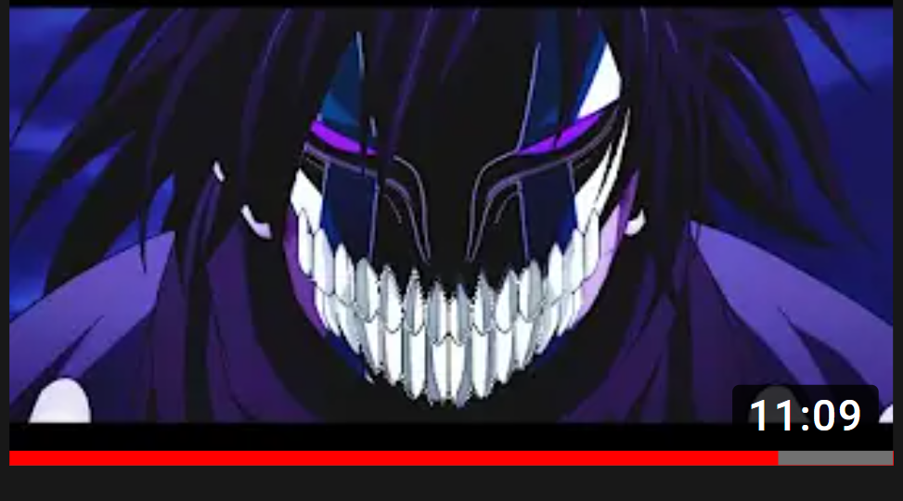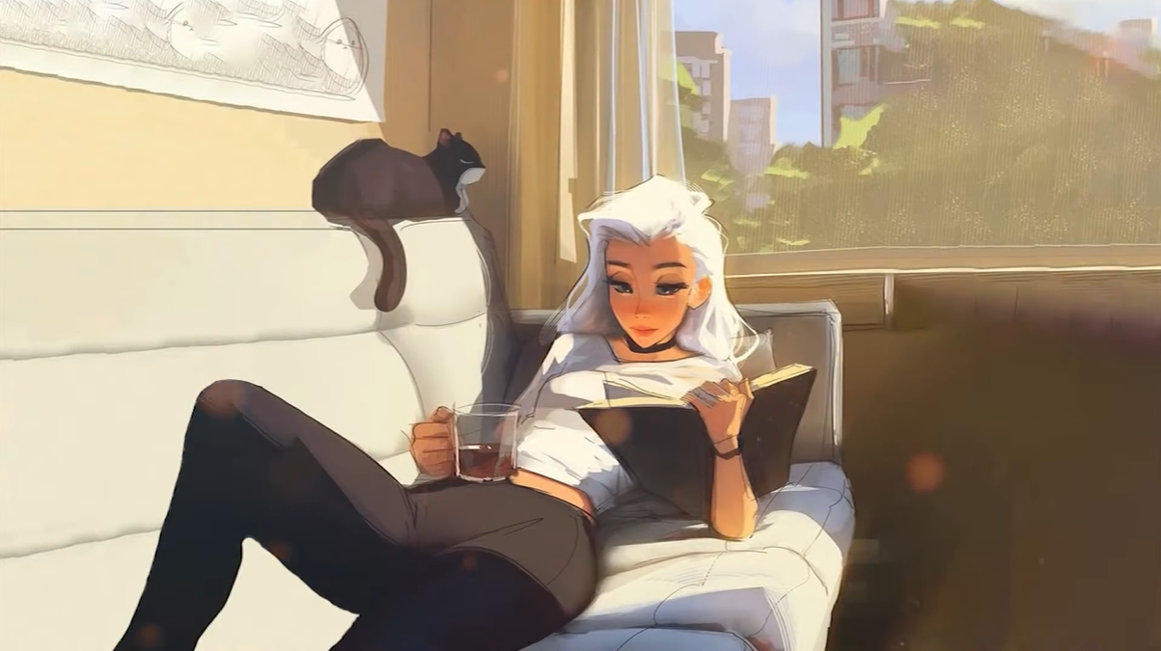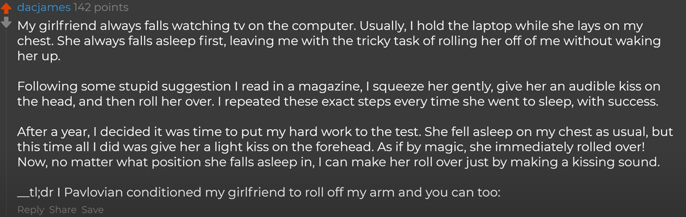

Kissing at the back of the neck to make them feel calm